Model: FO.MMDP.LC.50/125.xM (OM3)
x=Length: 1/2/3/5/10/15/20/30
Description: LC-LC Multimode Fiber Patchcord, Duplex
50/125µm (OM3) (1M/2M/3M/5M/10</15M/20M/30M)
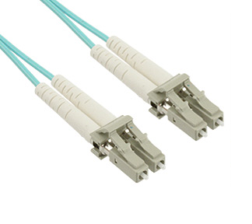
Features:
LC to LC Duplex 10Gb Multimode OM3 Fiber Optic Patch Cables by Amphenol offer unparalleled optical network performance at data-rates up to 10-Gigabits per second. Aqua OM3 Laser Optimized Multimode Fiber is well suited for 850nm VCSEL 10GBASE-SR link distances up to 300m (984 ft). Each 50/125um multimode fiber optic patch cable utilizes a Low Smoke Zero Halogen riser-rated jacket for compatibility with most datacenter and critical area applications. UPC type duplex LC connectors are pre-installed by an ISO:9001 certified factory with 30+ years experience. Cisco, Dell, HP and Brocade approved vendor.

Fiber Optic Patch Cord Technical Standard:
• Connectors: LC to LC Duplex Multimode UPC w/ Ceramic Ferrules
• Cable: 50/125um OM3 10Gb Laser Optimized Multimode Fiber (Zipcord)
• Jacket: Riser (OFNR), Plenum (OFNP), Low Smoke Zero Halogen (LSZH)
• Cord length: 1M/2M/3M/5M/10M/15M/20M/30M
• Ideal for 10-Gigabit Ethernet backbone installations up to 300m length
• Backward compatible with 50/125 OM2 & 62.5/125 OM1 fiber
• Precision-built, polished, and optically tested prior to shipment
• Full support for LED & VCSEL light sources @ 850nm & 1300nm
• High-grade halogen-free molded strain relief for added durability
• Insertion Loss: = 0.30 dB
• Return Loss: = 55 dB
• Durability: 500 mating cycles per EIA/TIA-568-B.3
• Bandwidth: 2000/500 MHz-km (OM3) @ 850/1300 nm
• RoHS Compliant
Applications:
• VCSEL applications
• FTTX
• 10 Gigabit networks
• LAN

